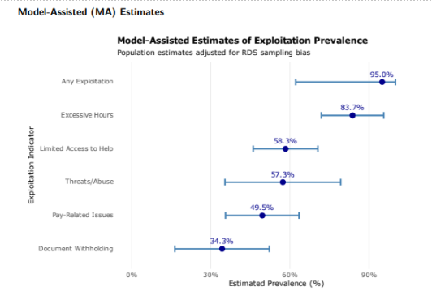
Figure 3 Forest Plot of Model-Assisted Binary Exploitation Estimates: Population prevalence estimates with 95% credible intervals for each exploitation indicator, ordered by prevalence magnitude. Error bars represent posterior uncertainty from Bayesian MA-RDS (N=980,000, sample seed selection). Source: Authors’ Own Work

